**Audio Steganography**

Digital Signal Processing Final Report



Group

June, 2021

**Table of Contents**

1.Introduction

1.1 Overview

- Steganography: is the technique of hiding secret data within an ordinary, non-secret, file or message in order to avoid detection; the secret data is then extracted at its destination.

- Embedding secret message into digital sound is called audio steganography.

- Audio Steganography: is presented where the bits of a secret message are embedded into the coefficients of a cover audio.

- The properties of the human auditory system (HAS) are exploited in the process of audio Steganography

- The goal of this project is to build an engine that steganographic the audio of our five team members.

1.2 Authors

Đoàn Văn Chương BA9-008

Nguyễn Minh Hiếu BA9-020

Đỗ Công Hòa BA9-022

Đào Hải Long BA9-041

Đặng Thái Sơn BA9-053

2 PROPOSED WORK

Audio Steganography is a broad topic and there are numerous way to achieve that goal. So our group has divided into smaller sections to test run some.In this section, the algorithms that were integrated in each sections model will be analyzed.

Block diagram of stenographic system:

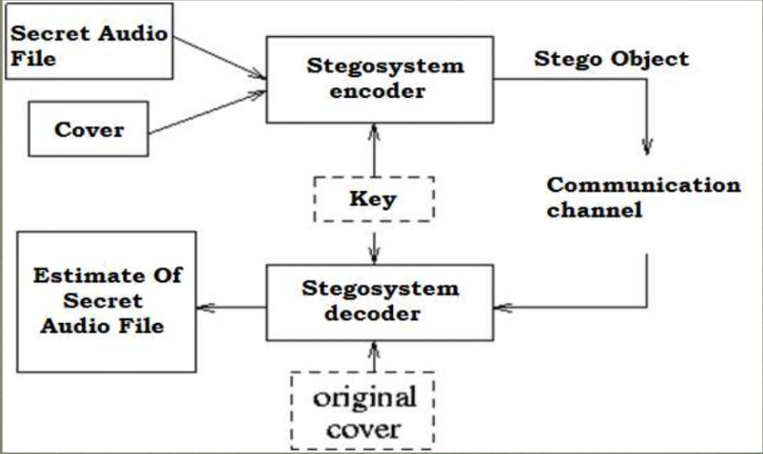

To embed data secretly onto digital audio file thre are few techniques introducted:

* Least Significaint Bits (LSB)
* Phase Coding
* Parity Coding
* Spread Spectrum

2.1 Least Significaint Bits (LSB)

+Flowchart of LSB modification Technique for Audio Steganography

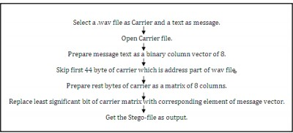

- Least Significant Bit (**LSB**) modification technique is the most simple and efficient technique used for audio steganography. The conventional LSB modification technique is vulnerable to steganalysis. This paper proposes two ways to improve the conventional **LSB** modification technique.

-The message ‘HEY’ is encoded in a 16-bits CD quality sample using the LSB method.Here the secret information is ‘HEY’ and the cover file is audio file. HEY is to be embedded inside the audio file.Firat the secret information ‘HEY’ and the audio file are converted into bits stream

-The least significant column of thr audio file is replaced by the bit stream of secret information ‘HEY’.The resulting file after embedding secret information ‘Hey’ is called Stego-file.

LSB method:

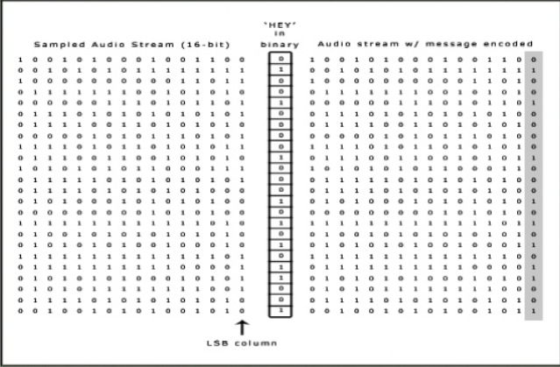

2.2 Phase Coding

The phase coding method works by substituting the phase of an initial audio segment with a reference phase that represents the data. The procedure for phase coding is as follows:

- The original sound sequence is broken into a series of N short segments.

- A Discrete Fourier transform (DFT) is applied to each segment, to break create a matrix of the phase and magnitude.

- The phase difference between each adjacent segment is calculated.

- For segment S0, the first segment, an artificial absolute phase p0 is created.

- For all other segments, new phase frames are created.

- The new phase and original magnitude are combined to get a new segment, Sn.

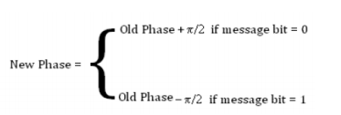

- Finally, the new segments are concatenated to create the encoded output.

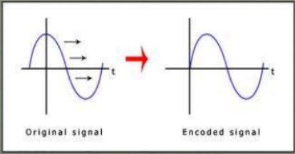

+ Flow-chart for audio steganographic technique using phase encoding

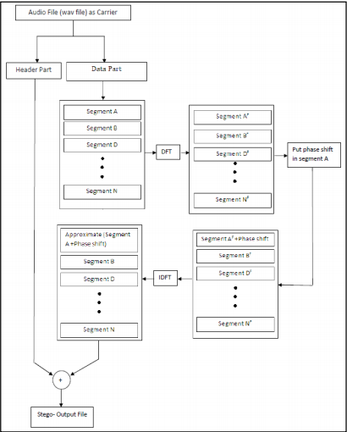

2.3 Parity Coding

- One of the prior works in audio data hiding technique is parity coding technique.

- Instead of breaking a signal down into individual samples, the parity coding method breaks a signal down into separate regions of samples.

- Encode each bit from the secret message in a sample region's parity bit. If the parity bit of a selected region does not match the secret bit to be encoded.This process flips the LSB of one of the samples in the region. Thus, the sender has more of a choice in encoding the secret bit, and the signal can be changed in a more unobtrusive fashion.

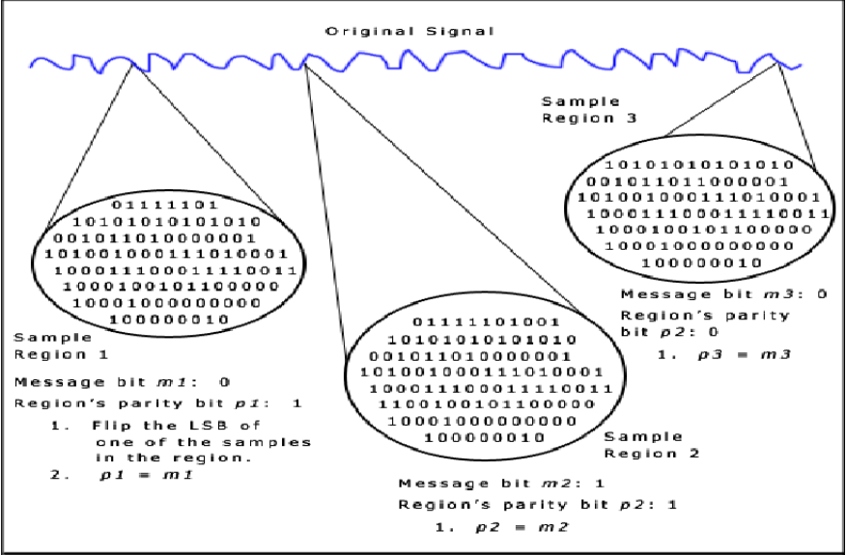

2.4 Spread spectrum

+ Spread Spectrum steganography on audio data will be implemented with the following scheme:

- Transform the audio cover object in time-domain into frequency- domain using Fast Fourier Transform.

-Adding the information signal by using spread-spectrum to the cover object in frequency-domain.

-Transform back the audio cover object from frequency –domain into time –domain using inverse fast Fourier Transform

+ The basic spread spectrum (SS) method attempts to spread secret information across the frequency spectrum of the audio signal.

+ This system is similar to a system which uses an implementation of the LSB that spreads the message bits randomly over the entire sound file.

+ Unlike LSB coding, the Spread Spectrum method spreads the secret information over the frequency spectrum of the sound file using a code which is independent of the actual signal.

+ As a result, the final signal occupies a bandwidth which is more than what is actually required for transmission.

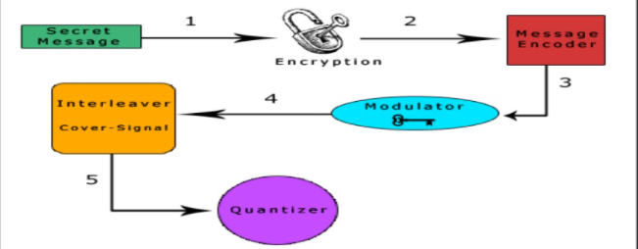

1. The scret message is encrypted using a symmetric key , k1.

2. The encrypted message is encoded using a low-rate error-correcting code.This step increasing the overall robustness of the system.

3. The encoded message is the modulated with a pseudorandom signal that was generated using a second symmetric key, k2,as a seed.

4. The resulting random signal contains the message is interleaved with the cover-signal

5. This process is reversed for message extraction.

3 Advantage and Disadvantage

3.1 Advantage

- Potential capability to hide the existence of confidential data.

-Hardness of detecting the hidden (i.e., embedded) data.

-Strengthening of the secrecy of the encrypted data.

3.2 Disadvantage

-The confidentiality of information is maintained by the algorithms, and if the algorithms are known then this technique is of no use.

- Password leakage may occur and it leads to the unauthorized access of data.

4 Applications

- Confidential communication and secret data storing.

- Protection of data alteration.

- Access control system for digital content distribution.

- Media Database systems .

- Alleged use by intelligence services.

5. Conclusion

The intent of this report was to cover some of the more common methods of data hiding using widespread file formats and easily available tools as an introduction ,to the primary concepts of steganography. These discussions should serve as a starting point to the exploration of more complex steganographic techniques involving, for example, the use of network packets and unused hard disk space as cover medium, or the more complex methodologies used on our audio files.

6. References

- S. William, Cryptography and Network Security: Principles and Practice, 2nd edition, Prentice-Hall, Inc., 1999 pp 23-50.

- Bloom. A. et al., 2008. Digital watermarking and Steganography. 2nd edition

- LSB Modification and Phase Encoding Technique of Audio Steganography Revisited : [11_LSB-Modification-and-Phase-Encoding-Technique-of-Audio-Steganography-Revisited.pdf (ijarcce.com)](https://ijarcce.com/wp-content/uploads/2012/06/11_LSB-Modification-and-Phase-Encoding-Technique-of-Audio-Steganography-Revisited.pdf)

- Audio Steganography by Different Methods: https://citeseerx.ist.psu.edu/viewdoc/download?doi=10.1.1.446.392&rep=rep1&type=pdf